**Exercise 2 **

Now the NC government wants to create a report for the NC grant utilization.

The NC grant manager wants to see a Power BI report of

* A slicer which can select Award Date time period
* Data cards to see three important numbers: Total Award, Actual Job Count, Actual Wage
* Actual Job Count and Required Job Count by Funding County
* Actual Wage and Required Wage by Funding County

Report example:

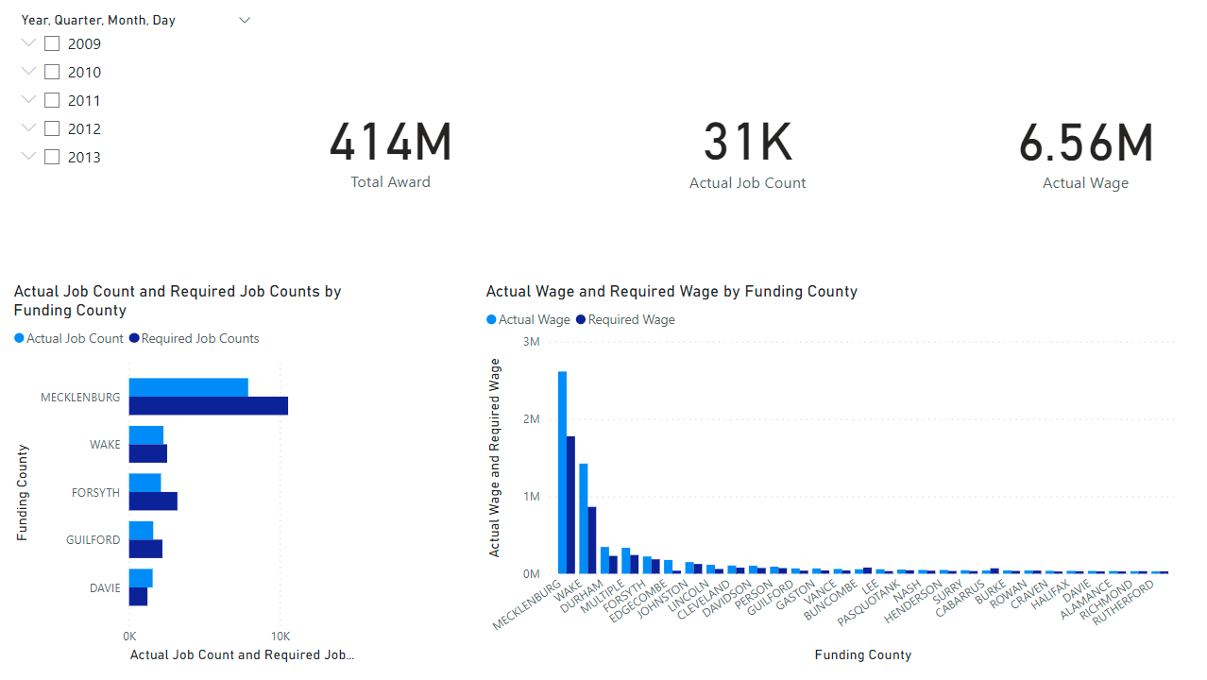

Tasks

* Use the visual level filter to select the top 5 counties by Actual job count in the bar chart.
* Use the visual level filter to select the counties whose actual wage is greater than $10,000 in the column chart.

Question

* What is the Total award, actual job created and actual wage created during 1/1/2012 -12/31/2012?
* What insights can you get from this report?